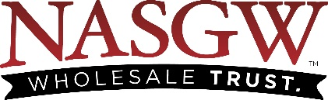

2023 Expo & Annual Meeting
Application & Contract for Exhibit Space

We, the undersigned, are a current active member of NASGW and do hereby make application for exhibit space as indicated below for our use at the 2023 NASGW Expo, October 25 – 27, 2023, Great Columbus Convention Center. We have read the Exhibitor Rules & Regulations and agree to comply with the 2023 rules governing the event.

Company Information
Company Name
Booth Name
(if different than above)
Contact Name
Mailing Address
City, State, Zip
Phone
Email Address
Please include secondary contact if needed

Exhibit Space Selection
Rental fee is $18.00/square foot (10x10 $1,800 for “in-line” booth space) & $20.00/square foot for “island” booth space (if available)

Current floor plan can be viewed at 2023 FLOOR PLAN

Booth# Choice ____________ Booth Size ______________ Total $_______________

Payment Information
Full payment is required at this time to secure your booth. Selection will not be finalized until payment is received.

Enclosed is (select one): |  |  |  |  |  | Full Payment |  |  |  | In the amount of |  |  |  |  | $
Method of Payment (U.S. Dollars Only) – Please circle one
Check |  |  | Visa |  |  |  | MasterCard |  |  |  |  | AMEX
Card # |  |  |  |  |  | Expiration
Name as it appears on card
Authorized Signature |  |  |  |  |  |  |  |  |  | Date

Please scan and e-mail your completed form to mpawelski@nasgw.org

